
A Project Report on
LLM-Powered Agentic Dashboard for
Business-Intelligence
Submitted in partial fulfilment for award of degree of
Master of Science
In Artificial Intelligence

Submitted by
Shyam Sundar K
R22MSA55

Under the Guidance of
Dr. JB Simha
Chief AI Officer, Adopt AI | Advisor & Mentor

REVA Academy for Corporate Excellence
REVA University
Rukmini Knowledge Park, Kattigenahalli,
Yelahanka, Bangalore – 560064

June, 2026



Candidate’s Declaration

I, Shyam Sundar K hereby declare that I have completed the project work towards the Master of Science in Artificial Intelligence at, REVA University on the topic entitled LLM-Powered Agentic Dashboard for Business Intelligence under the supervision of Dr. JB Simha. This report embodies the original work done by me in partial fulfilment of the requirements for the award of the degree for the academic year 2026

Place: Bengaluru Name of the Student: Shyam Sundar K
Date: Signature of Student:




Acknowledgment of Project Ownership and Usage Rights
I, Shyam Sundar K , a student enrolled in the Master of Science Program and 2026 Year at RACE, hereby acknowledge that any project, including but not limited to software, hardware, research, or other intellectual property created by me during my academic tenure at RACE, is the property of RACE, REVA University.
I understand and agree that RACE has the exclusive rights to use, reproduce, modify, or distribute the aforementioned projects for academic, research, and further development purposes. This includes the right to monetize, commercialize, or otherwise exploit the projects as deemed fit by RACE.
I acknowledge that I have no objection to RACE, REVA University, using, reproducing, or further developing the projects for the benefit of the institution and its academic community. I further affirm that any commercial or research activities related to the projects conducted by RACE shall not require additional consent or approval from me.
This acknowledgment is made willingly and without any reservations. I am grateful for the education and opportunities provided by RACE, and I recognize the importance of contributing to the academic and research goals of the institution.

Place: Bengaluru Name of the Student: Shyam Sundar K
Date: Signature of Student 



Certificate

This is to certify that the project work entitled LLM-Powered Agentic Dashboard for Business Intelligence has been carried out by Shyam Sundar K with SRN R22MSA55, who is a bonafide student of REVA University, is submitting the first year project report in fulfilment for the award of Master of Science in Artificial Intelligence during the academic year 2026. The Project report has been tested for plagiarism, and has passed the plagiarism test with the similarity score less than 15%. The project report has been approved as it satisfies the academic requirements in respect of the project work prescribed for the said degree.

Signature of the Guide Signature of the Director
Dr. JB Simha Dr. Shinu Abhi
Guide Director

External Viva
Names of the Examiners
- <Name> <Designation> <Signature>
- <Name> <Designation> <Signature>

Place: Bengaluru
Date:



Acknowledgement
I express my deepest gratitude to my mentors and trainers for their invaluable guidance, insights, and encouragement throughout this project. In particular, I sincerely thank Dr. Shinu - Director, Dr. J.B. Simha - Chief AI Officer, Adopt AI | Advisor & Mentor and Dr. Rashmi for their expert advice, continuous support, and motivation. Their mentorship has been instrumental in shaping my understanding and enhancing my problem-solving abilities.
I extend my heartfelt appreciation to my classmates and program office members for their constructive discussions, collaboration, and support, which have contributed significantly to the successful completion of this work. I am also deeply grateful to my family and friends for their unwavering encouragement, patience, and belief in me throughout this journey.
Furthermore, I would like toby the Hon’ble Chancellor, Dr. P Shayma Raju, Hon’ble Vice Chancellor, Dr. Sanjay Chitnis, and Registrar, Dr. M. Dhanamjaya. Their leadership, vision, and commitment to academic excellence have created an environment that fosters innovation and research
Lastly, I extend my gratitude to everyone who has directly or indirectly contributed to this project. Their support and encouragement have been invaluable in completing this work successfully.

Place: Bengaluru
Date: 16.08.2025



Similarity Index Report

This is to certify that this project report titled LLM-Powered Agentic Dashboard for Business Intelligence was scanned for similarity detection. The process and outcome are given below. The plagiarism report is attached in the appendix.

Software Used: Turnitin
Date of Report Generation:
Similarity Index in %:
Total word count:
Name of the Guide: Dr. JB Simha

Place: Bengaluru Name of the Student: Shyam Sundar K
Date: Signature of Student 

Verified by:

Signature
Dr. Shinu Abhi,
Director, Corporate Training

List of Abbreviations, Tables and Figures

1. List Of Abbreviations
Sl. No. | Abbreviation | Long Form
1 | AI | Artificial Intelligence ​
2 | BI | Business Intelligence ​
3 | LLM | Large Language Model ​
4 | GPT | Generative Pre-Trained Transformer ​
5 | API | Application Programming Interface ​
6 | CSV | Comma Separated Values ​
7 | IQR | Interquartile Range ​
8 | UML | Unified Modelling Language (Mentioned As UML/Draw.Io Diagrams) ​
9 | TDSP | Team Data Science Process
10 | RAM | Random Access Memory ​
11 | CPU | Central Processing Unit ​

2. List Of Tables
Table No. | Title (As Used In Report) | Page No.
Table 5.1 | TDSP Phases | 22
Table 5.2 | Objective–Methodology Alignment | 23
Table 6.1 | Hardware Requirements | 24
Table 6.1 | Software Requirements | 24
Table 9.1 | Functional Test Results | 41
Table 9.2 | Performance Validation Metrics | 41
Table 9.3 | End-to-End Validation Results | 42

3. List Of Figures
Figure No. | Title | Page No.
Fig. 5.1 | TDSP-Driven Methodology for the Proposed LLM-Powered Agentic Dashboard | 21
Fig 7.1 | Agentic Workflow Architecture of the Proposed LLM-Powered Agentic Dashboard | 28
Fig. 8.1 | State Definition for LangGraph Workflow (State TypedDict) | 31
Fig. 8.2 | Query Relevance Node Implementation (Code Snippet) | 32
Fig. 8.3 | Query Enhancer Node Implementation (Code Snippet) | 33
Fig. 8.4 | Data Preprocessor Node Implementation (Code Snippet) | 33
Fig. 8.5 | Plot Selector Implementation (Code Snippet) | 34
Fig. 8.6 | Output Checker Implementation (Code Snippet) | 34
Fig. 8.7 | Workflow Assembly And Graph Compilation Code | 35
Fig. 8.8 | Dynamic Dash Layout Generation (Run_Dashboard Function) | 36
Fig. 8.9 | Chart Type Implementation (Update_Chart_Sub_Func) | 36
Fig. 8.10 | Temporal Sorting Logic For Month And Day-Of-Week | 37
Fig. 8.11 | Filter UI Components For Categorical Filters | 37
Fig. 8.12 | Filter UI Components For Numerical Filters | 37
Fig. 8.13 | Filter Application Logic (Categorical And Numerical) | 38
Fig. 8.14 | Empty Data Handling Logic | 38
Fig. 8.15 | Bar-Chart Specific Insight Preparation Code | 39
Fig. 8.16 | Scatter-Plot Specific Insight Preparation Code | 39
Fig. 8.17 | Line-Chart Statistics Calculation Code | 39
Fig. 8.18 | Insight Prompt Engineering Code Snippet | 40
Fig. 8.19 | Streamlit Frontend Implementation (Stream_Lit.Py) | 40
Fig. 9.1 | Distributor-Wise Sales Bar Plot (System Output) | 43
Fig. 9.2 | Distributor Performance Insights (System Output) | 43
Fig 10.1 | Monthly Sales Value Trend Using a Line Chart | 46
Fig 10.2 | Category-Wise Sales Distribution Using a Pie Chart | 46
Fig 10.3 | Category-Wise Sales Value Distribution Using a Box Plot | 46

Abstract
Business intelligence tools have come a long way, but they still have a major problem. Traditional BI platforms like Tableau and Power BI require analysts to spend a lot of time manually configuring each dashboard. Business managers cannot simply ask a question in plain English and get instant answers with charts and explanations. This creates bottlenecks, slows down decisions, and keeps analytics locked behind technical expertise.
This project aims to build an LLM-Powered agentic dashboard system that turns natural language questions into interactive visualizations with contextual insights automatically. The goal is to cut the time from question to insight from several hours down to a few minutes. The system accepts free-form questions, processes data intelligently, picks the right chart types, provides interactive filters, and explains what the visualizations mean in business terms.
The project follows TDSP methodology using a sales dataset with product categories, distributors, and order dates. A multi-agent workflow built with LangGraph coordinates five specialized agents: a query relevance checker validates questions against available data, a query enhancer rewrites vague questions, a data preprocessor cleans columns and handles outliers using IQR methods, a plot selector uses GPT to generate chart configurations, and an output validator checks configurations and triggers retries when needed. The system uses Dash to build dashboards with six chart types (bar, scatter, line, box, histogram, pie), categorical and numerical filters, and Perplexity API for insights. A Streamlit interface lets users type questions and launch dashboards.
Testing demonstrated that real business queries could be transformed into complete dashboards with contextual insights while significantly reducing manual analytical effort. Most evaluated queries were processed within 60 seconds, generated visualizations accurately represented the underlying data, and interactive filters responded correctly to user selections. The system operates on standard laptop hardware, making advanced business intelligence capabilities more accessible and efficient.
Keywords: Business Intelligence, Interactive Dashboard, Agentic AI, LangGraph, Dash, Natural Language Queries, LLM Powered.

Table of Contents

Candidate’s Declaration 2
Acknowledgment of Project Ownership and Usage Rights 3
Certificate 4
Acknowledgement 5
Similarity Index Report 6
List of Abbreviations, Tables and Figures 7
Abstract 9
Table of Contents 10
Chapter 1: Introduction 11
Chapter 2: Literature Review 13
Chapter 3: Problem Statement 17
Chapter 4: Objectives of the Study 18
Chapter 5: Project Methodology 19
Chapter 6: Resource Requirement Specification 24
Chapter 7: Software Design 27
Chapter 8: Implementation 30
Chapter 9: Testing and Validation (excerpt for 2 examples) 40
Chapter 10: Analysis and Results 43
Chapter 11: Conclusions and Future Scope 46
Bibliography 47
Plagiarism Report 49
Github Link 50

Chapter 1: Introduction
1.1 Background Information
Business intelligence has changed dramatically over the past two decades. What started as simple spreadsheet reporting now processes millions of data points in seconds. Companies collect massive amounts of data, but making sense of it remains challenging.
Traditional BI tools like Tableau and Power BI work well for creating charts and graphs, but they have a major limitation: they require extensive manual setup. A data analyst typically spends several minutes configuring each dashboard, choosing visualizations, and setting up filters. This becomes a bottleneck when business users need quick answers .
AI and large language models have opened new possibilities. Machines can now understand natural language questions, process complex datasets, and explain findings in plain English [1]. But most BI dashboards don't connect to these AI systems. A business manager might ask "Which distributors generated the highest sales?" but still needs a technical analyst to build the dashboard [2].
This gap between AI capabilities and visualization tools is the problem this project addresses. Businesses need systems that can turn natural language questions into visual insights quickly, without sacrificing clarity.
1.2 Need for the Study
Current dashboard technologies have three fundamental problems. First, they lack direct integration with AI processing pipelines, forcing analysts to manually recreate AI-generated insights in dashboard form. Second, dashboards display visualizations without contextual explanations, leaving business users to interpret complex patterns on their own [3]. Third, manual configuration creates delays when rapid decision-making is critical.
These limitations impact stakeholders differently. Data analysts spend time on repetitive dashboard work instead of strategic analysis. Business managers make decisions with incomplete understanding of data patterns. Organizations that cannot quickly translate questions into visual insights fall behind more agile competitors. An automated system that bridges natural language queries, AI processing, and self-explanatory visualizations addresses these gaps directly.
1.3 Scope of the Study
This project aims to develop an LLM-Powered Agentic dashboard that enables users to analyse business data through natural language queries. The proposed system is intended to combine LLM intelligence, data visualization, and business intelligence techniques to simplify the process of generating analytical insights from structured datasets.
The scope of the project includes designing an agent-driven workflow for query processing, automated data preparation, visualization selection, and insight generation. The system is planned to provide interactive dashboards capable of presenting business information through multiple chart formats along with explanatory insights. The study focuses on structured business datasets, such as sales and operational data, and seeks to make data analysis more accessible to both technical and non-technical users through a user-friendly interface.
1.4 Potential Impact and Applications
The proposed system is expected to reduce the effort and time required to transform business questions into meaningful visual insights. By allowing users to interact with data using natural language, the project aims to improve accessibility to analytics and support faster decision-making across organizations.
The approach has potential applications in domains such as sales, healthcare, manufacturing, finance, and education, where timely interpretation of data is important. By simplifying data exploration and reducing dependence on technical expertise, the project seeks to contribute toward wider adoption of data-driven decision-making within organizations and communities.

Chapter 2: Literature Review
Business Intelligence and data visualization have become increasingly important as organizations generate larger volumes of data. Researchers have proposed various solutions involving automated analytics, visualization, recommendation, explainable AI, and agent-based systems to support data-driven decision-making. This chapter reviews key studies in these areas, identifies existing gaps, and establishes the foundation for the proposed LLM-Powered Agentic dashboard system.
2.1 AI for Visualization
Wu et al. introduced the concept of AI4VIS, which explores the integration of Artificial Intelligence techniques into the visualization process. Their survey explains how machine learning and deep learning models can support visualization tasks such as chart recommendation, layout optimization, and automated insight discovery. The study highlights the growing shift from manually designed visualizations toward intelligent systems that can assist users in selecting suitable visual representations for data analysis [1].
Although the survey demonstrates the potential of AI-assisted visualization, it primarily focuses on individual visualization tasks rather than complete end-to-end analytical systems. The work also does not address how business users can interact with data through natural language. This creates an opportunity to investigate systems that combine query understanding, visualization generation, and insight delivery within a single workflow. The proposed project aims to address this gap by enabling users to generate dashboards directly from natural language questions.
2.2 Big Data Visualization Challenges
Bikakis examines the challenges associated with visualizing large and complex datasets. The study discusses issues such as data heterogeneity, scalability, data quality, and user adaptability, emphasizing that effective visualization depends not only on graphical representation but also on proper data preparation and transformation [4].
The research identifies preprocessing as a critical requirement for successful analytics but focuses mainly on challenges rather than providing an integrated solution. Similarly, Tawakuli et al. demonstrate the importance of automated preprocessing techniques for improving analytical outcomes . These studies suggest that data preparation remains a significant bottleneck in analytics workflows. Motivated by these findings, the proposed project incorporates automated preprocessing mechanisms to prepare datasets before visualization generation .
2.3 AI-Driven Dashboard Recommendation
Wu et al. proposed MultiVision, a deep learning-based framework for recommending dashboard layouts and multiple visual views [5]. The study treats dashboard generation as a recommendation problem and demonstrates how machine learning can assist users in identifying effective combinations of charts for analytical tasks.
While MultiVision contributes significantly to automated dashboard design, it relies on specialized models and focuses primarily on visual recommendation. The approach provides limited support for conversational interaction and dynamic analytical reasoning. This reveals a gap for systems that can generate dashboard configurations directly from user questions while adapting to different datasets. The proposed project seeks to explore this possibility through the use of language models and intelligent workflow orchestration.
2.4 Human–AI Collaboration in Analytics
North argues that effective analytics systems should support collaboration between humans and computational tools rather than replacing human decision-making entirely. The study emphasizes the importance of interactive exploration, explanation, and user involvement throughout the analytical process [6].
This perspective highlights that successful analytics platforms must balance automation with user control. However, the work does not provide a practical framework for integrating modern AI capabilities into dashboard systems. The proposed project builds on this principle by allowing users to guide analysis through natural language queries while AI components assist with data preparation, visualization generation, and insight creation.
2.5 Agentic AI and Workflow Orchestration
LangGraph introduces a framework for building stateful, multi-step workflows involving multiple AI components [7]. Similarly, Ouyang et al. present an agent-based approach in which different agents collaborate to transform natural language requests into visual outputs while validating intermediate results. These studies demonstrate the advantages of decomposing complex tasks into specialized stages [8].
Despite their strengths, existing agentic systems largely focus on workflow design and natural-language-to-visualization generation rather than complete business intelligence applications. Questions remain regarding how such architectures can be applied to practical dashboard environments with data preprocessing, visualization selection, validation, and user interaction. This gap motivates the development of an integrated agent-driven dashboard workflow in the proposed study.
2.6 Dashboard Design and Interaction Principles
Few presents foundational principles for effective dashboard design, emphasizing clarity, minimal visual clutter, and efficient communication of information [9]. Similarly, Shneiderman proposes the widely adopted principle of “overview first, zoom and filter, then details on demand,” which has influenced the design of many modern visualization systems [10].
These studies establish important guidelines for dashboard usability but do not address how dashboards can be generated automatically from user intent. As organizations increasingly seek self-service analytics solutions, there is a need to combine established dashboard design principles with intelligent automation. The proposed project intends to apply these principles while exploring automated dashboard generation techniques.
2.7 Explainable AI and Automated Insight Generation
Ribeiro et al. introduced LIME, demonstrating the importance of explanations in improving user trust and understanding of AI-generated outputs. More recently, Mersha et al. highlighted the growing role of Explainable AI and emphasized the effectiveness of natural language explanations for non-technical users [3].
Although explainability has received significant attention, many visualization systems still rely primarily on charts and graphs without providing contextual interpretations. This creates a gap between data presentation and user understanding. The proposed project aims to bridge this gap by investigating the integration of visualization outputs with automatically generated textual insights that help users interpret analytical results more effectively.
2.8 Summary Research gap
The literature reviewed highlights significant advancements in artificial intelligence, data visualization, business intelligence, explainable AI, and agent-based analytical systems. While existing studies have demonstrated the potential of AI-assisted visualization, dashboard recommendation, automated data preprocessing, and intelligent workflow orchestration, most solutions focus on specific analytical tasks rather than providing a complete end-to-end business intelligence environment.
The common Research Gaps Identified:
- Limited integration of natural language queries with automated dashboard generation.
- Dependence on manual data preparation and analytical workflows.
- Lack of contextual business insights alongside visualizations.
- Limited adoption of unified agent-driven architectures for business intelligence.
- Need for accessible solutions that support both technical and non-technical users.
Therefore, there is a need for an intelligent business intelligence platform that integrates natural language interaction, automated data preparation, visualization generation, and contextual insight creation within a single workflow. This identified gap provides the motivation for the proposed LLM-Powered Agentic Dashboard for Business Intelligence.

Chapter 3: Problem Statement
Current business intelligence platforms often require users to manually prepare data, create visualizations, and design dashboards before insights can be obtained. This dependence on technical knowledge and manual effort creates barriers to efficient data analysis, particularly for users with limited analytical expertise. As a result, businesses may take longer to turn data into meaningful decisions.
In response to these challenges, organizations are increasingly looking for more intuitive and intelligent ways to interact with their data. Recent advances in artificial intelligence, natural language processing, and agent-based systems have created opportunities to simplify analytical workflows and make business intelligence more accessible to a wider range of users. A solution that enables users to ask questions in natural language, automatically prepare data, generate suitable visualizations, and provide contextual insights through an interactive dashboard could significantly improve the efficiency of data analysis. Therefore, the development of an LLM-Powered Agentic dashboard represents a relevant and timely approach to addressing current limitations in business intelligence and supporting more effective data-driven decision-making.

Chapter 4: Objectives of the Study
The proposed study aims to develop an LLM-Powered Agentic Dashboard for generating visual insights from business data. The project is guided by four objectives that define the scope of the proposed solution.
4.1 Design an intelligent workflow for natural language-driven business data analysis and visualization.
Design an intelligent workflow that interprets natural language queries, prepares data for analysis, selects appropriate visualizations, and validates outputs before dashboard generation. This objective establishes the core analytical process that transforms user requests into meaningful visual insights.
4.2 Develop an interactive dashboard for dynamic data exploration and visualization generation.
Develop an interactive dashboard that dynamically generates visualizations and supports data exploration through filtering and user interaction features. The objective focuses on creating a unified environment for efficient and accessible analysis.
4.3 Evaluate the accuracy, reliability, and effectiveness of analytical outputs and insights.
Evaluate the accuracy, reliability, and usefulness of generated visualizations and insights. This objective focuses on validating system performance and ensuring that outputs accurately represent the underlying data and support informed decision-making.
4.4 Deploy an accessible business intelligence solution for intuitive decision support and reporting.
Deploy a user-friendly business intelligence solution that enables users to submit natural language queries, interact with dashboards, and access insights through an intuitive interface. The objective aims to make business intelligence more accessible to both technical and non-technical users.
The four objectives provide a structured framework for the development and evaluation of the proposed LLM-Powered Agentic Dashboard.

Chapter 5: Project Methodology
This study follows the Team Data Science Process (TDSP) to guide the development of the proposed LLM-Powered Agentic dashboard [11]. TDSP provides a structured framework for transforming business requirements into deployable analytical solutions through a sequence of interconnected phases. The methodology, as shown in Fig. 5.1 involves natural language interaction, automated data preparation, intelligent visualization generation, dashboard deployment, and validation of analytical outputs.
The six phases applied in this study are Business Understanding, Data Acquisition and Understanding, Data Preparation, LLM Agentic Workflow, Deployment, and Customer Acceptance and Validation.
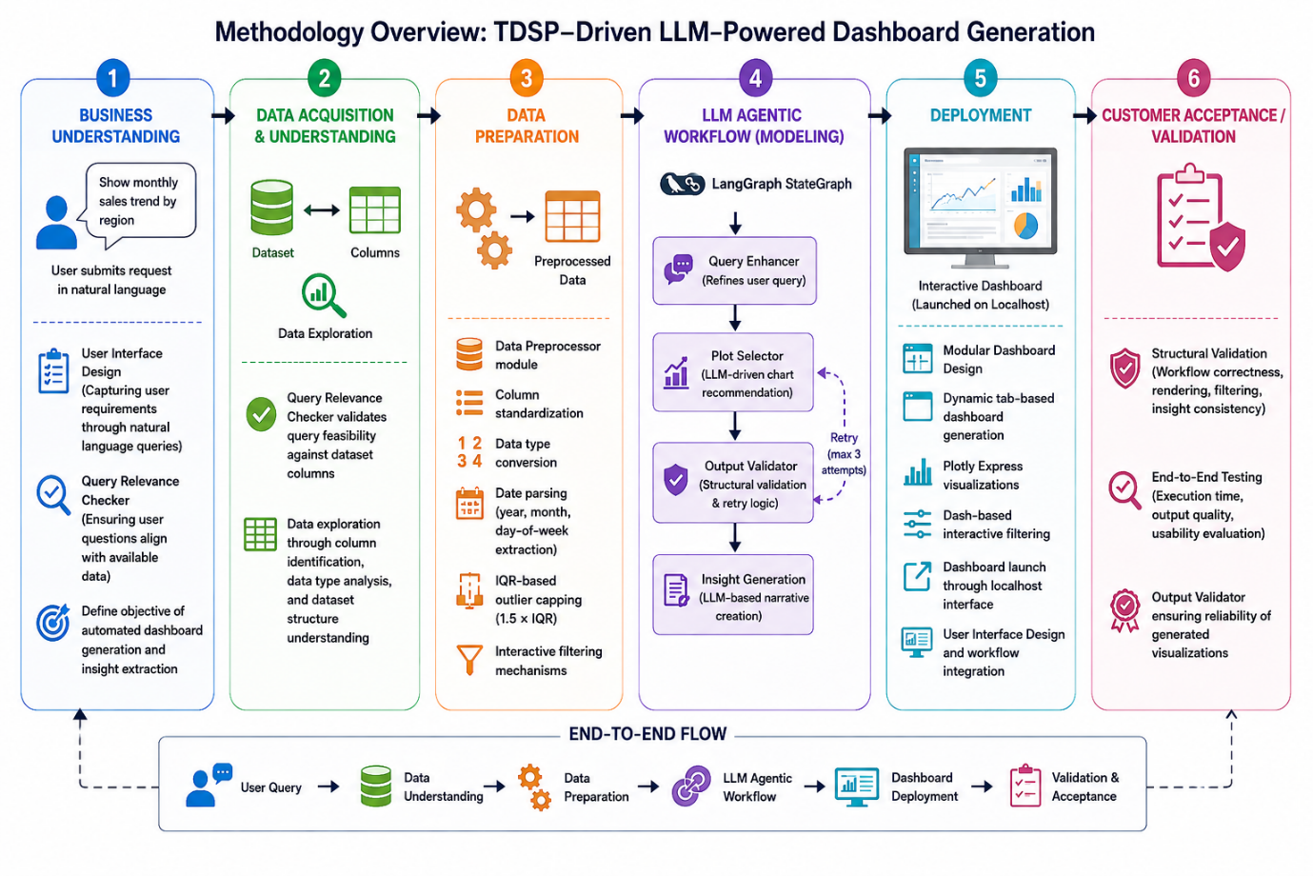
Fig 5.1: TDSP-Driven Methodology for The Proposed LLM-Powered Agentic Dashboard

5.1 Business Understanding
The first phase focuses on identifying the analytical requirements of end users and defining the purpose of the proposed solution. Users interact with the system through natural language queries rather than traditional dashboard configuration methods.
A Query Relevance Checker is used to determine whether the submitted request can be supported by the available dataset. This ensures that only meaningful and feasible analytical requests proceed through the workflow. The outcome of this phase is a clearly defined objective for dashboard generation and insight extraction.
5.2 Data Acquisition and Understanding
Once a query is accepted, the system examines the available dataset to understand its structure and suitability for analysis. This includes identifying dataset columns, examining data types, and understanding the relationships between available attributes.
The Query Relevance Checker also validates whether the requested analysis can be mapped to the dataset fields. This step helps ensure that subsequent processing stages operate on appropriate and relevant data.
5.3 Data Preparation
The Data Preparation phase focuses on transforming raw data into a format suitable for analysis and visualisation.
A dedicated Data Preprocessor module performs several automated operations, including:
- Column standardization
- Data type conversion
- Date parsing and feature extraction
- IQR-based outlier treatment [12]
- Preparation of interactive filtering options
Additional date-related attributes, such as year, month, and day of the week, are generated where applicable to support time-based analysis. These preprocessing activities improve data quality and ensure consistency throughout the workflow.
5.4 LLM Agentic Workflow
The core analytical processing is performed through an LLM-driven agentic workflow implemented using LangGraph StateGraph [7]. Instead of relying on a single processing step, the workflow uses specialized components that collaborate to generate visualisations and insights.
The workflow consists of:
- Query Enhancer – refines user requests into structured analytical instructions.
- Plot Selector – recommends suitable chart types based on the analytical objective and available data.
- Output Validator – verifies the correctness of generated outputs and applies retry logic when necessary.
- Insight Generator – produces narrative explanations that accompany the generated visualisations.
Together, these components transform natural language requests into structured analytical outputs that can be presented through an interactive dashboard.
5.5 Deployment
The generated analytical outputs are delivered through a modular dashboard environment built using Dash and Plotly.
The dashboard supports:
- Dynamic tab-based visualisation generation
- Interactive filtering controls
- Real-time data exploration
- Automatic dashboard rendering through a web interface
The separation between workflow processing and dashboard rendering allows the system to remain flexible while supporting multiple visualisation types and analytical scenarios.
5.6 Customer Acceptance and Validation
The final phase focuses on evaluating the reliability and usability of the proposed solution.
Validation activities include:
- Structural validation of workflow execution
- Verification of dashboard rendering and filtering behaviour
- Consistency checking of generated insights
- End-to-end testing of the complete analytical process
- Usability assessment for non-technical users
These activities help confirm that the system produces reliable visualisations and meaningful analytical insights while remaining accessible to intended users.
5.7 Methodology Mapping
Relationship Between The TDSP Phases And The Corresponding Components Implemented Within The Proposed System is shown in Table 5.1. This mapping illustrates how each phase of the methodology contributes to the overall functionality of the LLM-Powered Agentic Dashboard.
Table 5.1: TDSP Phases
Phase | Methodology Components
Business Understanding | User Interface Design, Query Relevance Checker, and analytical objective definition
Data Acquisition and Understanding | Dataset exploration, column identification, data type analysis, query feasibility validation
Data Preparation | Data Preprocessor, standardization, type conversion, date parsing, outlier treatment, filtering preparation
LLM Agentic Workflow | Query Enhancer, Plot Selector, Output Validator, Insight Generator, LangGraph orchestration
Deployment | Dynamic dashboard generation, Plotly visualizations, Dash integration, interactive filtering
Customer Acceptance and Validation | Structural validation, end-to-end testing, usability evaluation, and output reliability assessment
5.8 Objective–Methodology Alignment
To ensure that the proposed methodology directly supports the objectives of the study, each objective is aligned with one or more phases of the Team Data Science Process (TDSP). This alignment demonstrates how the activities performed throughout the project contribute to the achievement of the intended outcomes. The relationship between the study objectives and the corresponding TDSP phases is presented in Table 5.2.
Table 5.2: Objective–Methodology Alignment
Objective | Related TDSP Phase(s) | Purpose
Design an Intelligent Workflow for Natural Language-Driven Business Data Analysis and Visualization | Business Understanding, Data Acquisition and Understanding, Data Preparation, LLM Agentic Workflow | Helps convert natural language queries into meaningful analytical outputs through data preparation, visualization selection, and workflow processing.
Develop an Interactive Dashboard for Dynamic Data Exploration and Visualization Generation | Data Preparation, LLM Agentic Workflow, Deployment | Supports the creation of interactive dashboards that allow users to explore data and view generated visualizations.
Evaluate the Accuracy, Reliability, and Effectiveness of Analytical Outputs and Insights | Customer Acceptance and Validation | Ensures that generated visualizations and insights are accurate, reliable, and useful for analysis.
Deploy an Accessible Business Intelligence Solution for Intuitive Decision Support and Reporting | Deployment, Customer Acceptance and Validation | Provides an easy-to-use platform that enables users to access dashboards, insights, and reporting features.
As shown in Table 5.2, the four study objectives collectively span the complete development lifecycle of the proposed system. While some objectives are supported by multiple TDSP phases, each phase contributes directly to the achievement of one or more project objectives.

Chapter 6: Resource Requirement Specification
This chapter presents the resources required for the development, execution, and validation of the proposed LLM-Powered Agentic Dashboard for Business Intelligence. The selected resources were chosen to support natural language query processing, automated visualization generation, interactive dashboard deployment, and insight generation while maintaining ease of implementation and reproducibility.
6.1 Hardware Requirements
The proposed system was developed and tested on a standard personal computer environment without requiring specialised hardware. The minimum hardware requirements are shown in Table 6.1.
Table 6.1: Hardware Requirements
Component | Specification
Processor | Intel Core i5/i7 or AMD equivalent
Memory | 8–16 GB RAM
Storage | 256 GB SSD or higher
Internet | Stable broadband connection
Operating System | Windows 10/11, Linux, or macOS
These specifications are sufficient for data preprocessing, dashboard rendering, API communication, and execution of the LLM-driven workflow.
6.2 Software Requirements
The system was implemented using open-source technologies and widely adopted Python libraries.
Table 6.2: Software Requirements
Component | Tool / Library | Purpose
Programming Language | Python 3.9+ | Core application development
Data Processing | Pandas, NumPy | Data manipulation and analysis
Visualization | Plotly, Dash | Interactive chart and dashboard generation
User Interface | Streamlit | Natural language query interface
Workflow Orchestration | LangGraph | Multi-agent workflow management
LLM Integration | OpenAI SDK | Communication with Perplexity LLM API
Utility Libraries | JSON, OS, Multiprocessing | Configuration and process management
The selected software stack shown in Table 6.2 enables rapid development, modular design, and scalability while supporting real-time analytical interactions.
6.3 Dataset Requirements
The study utilizes a structured sales transaction dataset containing attributes such as voucher numbers, transaction dates, product descriptions, product categories, transaction types, quantities, rates, sales values (INR), and distributor information. The dataset serves as the knowledge source for visualization generation, filtering operations, and business insight extraction.
The dataset was selected because it contains both categorical and numerical variables suitable for demonstrating business intelligence, dashboard generation, and analytical exploration scenarios.
6.4 API and Access Requirements
The proposed system relies on external Large Language Model services for query enhancement, visualization planning, and insight generation. Access requirements include:
- Active Perplexity/OpenAI-compatible API credentials.
- Secure storage of API keys through environment variables.
- Local network access for Streamlit and Dash services.
- Internet connectivity for API communication and response retrieval.
These resources enable the system to transform natural language business questions into structured analytical outputs and contextual explanations.
6.5 Summary
The combination of standard computing hardware, open-source software libraries, structured business datasets, and LLM API services provides the necessary foundation for implementing the proposed dashboard system. The selected resources ensure that the solution remains cost-effective, reproducible, and capable of supporting real-time business intelligence and visualization requirements.

Chapter 7: Software Design
The proposed LLM-Powered Agentic Dashboard for Business Intelligence is designed using a layered architecture that transforms natural language business queries into interactive visual dashboards and business insights. As shown in Fig 7.1 The architecture consists of three major layers: the User Interaction Layer, the Agentic Processing Layer, and the Dashboard Generation Layer. This design enables users to interact with business data through natural language while automating dashboard creation and insight generation.
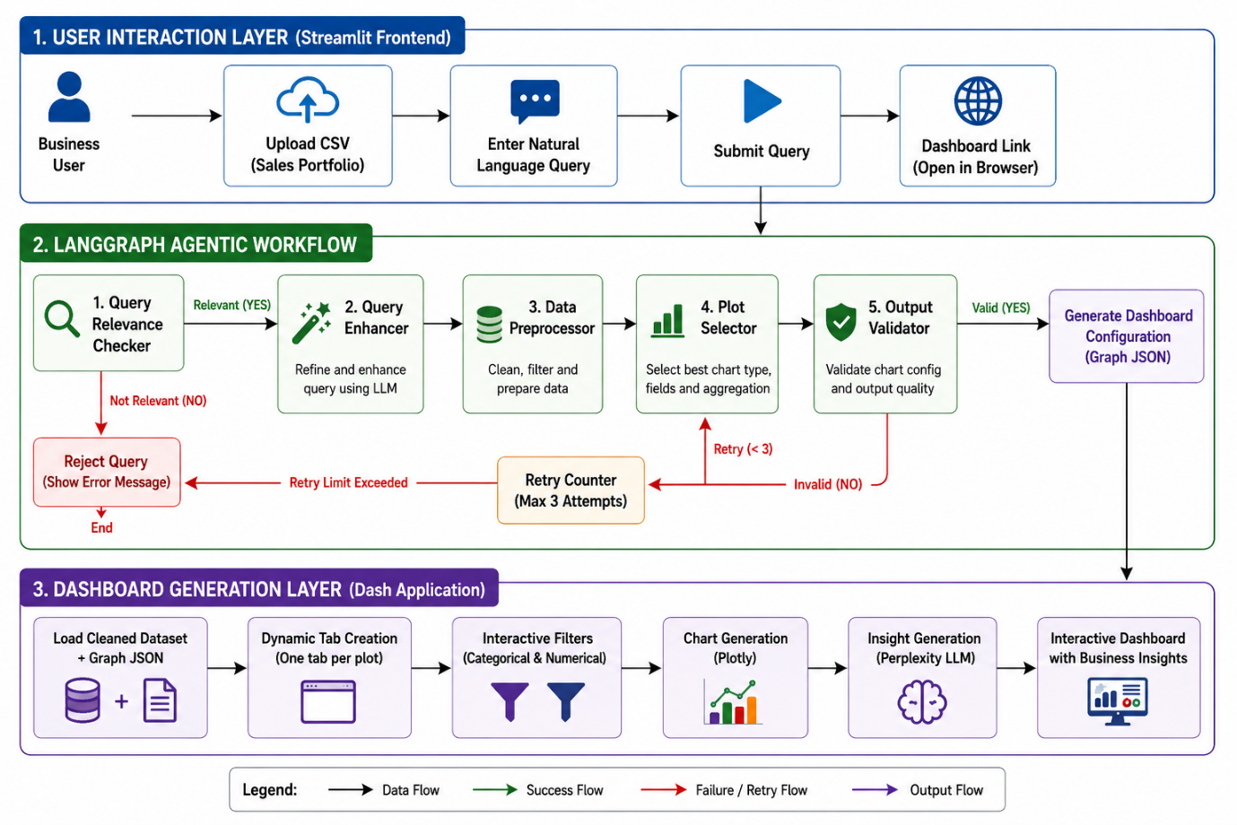Fig 7.1: Agentic Workflow Architecture Of The Proposed LLM-Powered Agentic Dashboard
7.1 User Interaction Layer
The User Interaction Layer serves as the entry point to the system and is implemented using Streamlit. Through a simple web interface, users can upload a business dataset and submit analytical questions in natural language. This layer is designed to improve accessibility by allowing users to express their analytical requirements using everyday business language rather than technical queries. Once the dataset and query are provided, the information is forwarded to the agentic workflow for further processing.
7.2 Agentic Processing Layer
The Agentic Processing Layer forms the intelligence core of the system and is implemented using a LangGraph-based workflow. The workflow consists of multiple specialised agents that collaboratively transform a user request into a dashboard configuration.
The process begins with the Query Relevance Checker, which verifies whether the submitted query is related to the uploaded dataset. Relevant queries are passed to the Query Enhancer, where the request is refined to improve clarity and analytical intent. The Data Preprocessor then performs data cleaning and preparation to ensure that the dataset is suitable for analysis.
The processed data is subsequently analysed by the Plot Selector, which determines appropriate visualizations, chart attributes, and filtering options. The generated configuration is validated by the Output Validator before dashboard generation. To improve reliability, the workflow includes a retry mechanism that automatically regenerates the configuration when validation requirements are not satisfied.
This multi-agent design allows the system to process user requests in a structured manner while improving the quality and consistency of generated dashboards.
7.3 Dashboard Generation Layer
After a valid dashboard configuration is produced, the Dashboard Generation Layer creates the final analytical interface using Dash and Plotly. Based on the generated configuration, the system dynamically creates dashboard tabs, visualizations, and interactive filtering controls. Users can further explore the data through categorical and numerical filters without requiring additional dashboard development.
To complement visual analytics, a Large Language Model (LLM) generates business insights from the visualized data. These insights help users understand trends, patterns, and key observations derived from the generated charts.
The final output is an interactive dashboard that combines visual exploration and AI-generated insights within a unified decision-support environment.
7.4 Design Considerations
The proposed architecture was developed with several key design considerations:
- Modularity: Individual components perform dedicated responsibilities, simplifying maintenance and future enhancements.
- Scalability: New agents, visualizations, datasets, and analytical capabilities can be integrated with minimal architectural changes.
- Reliability: Validation and retry mechanisms improve the consistency and quality of generated outputs.
- Usability: Natural language interaction reduces the technical barrier associated with traditional business intelligence tools.
- Extensibility: The architecture can support additional data sources and alternative LLM services in future implementations.
7.5 Architecture–Methodology Alignment
The proposed architecture was designed to support the TDSP phases used in this study. The User Interaction Layer helps users submit queries and datasets, supporting the Business Understanding and Data Acquisition phases. The Agentic Processing Layer handles data preparation, query processing, visualization selection, and insight generation. The Dashboard Generation Layer creates interactive dashboards and visualizations, allowing users to explore results and evaluate the generated outputs. This alignment ensures that the system architecture supports each stage of the methodology used to develop the proposed LLM-Powered Agentic Dashboard.
7.6 Conclusion
The software design integrates natural language interaction, agentic workflow orchestration, automated dashboard generation, and AI-driven insight creation into a unified platform. The layered architecture provides a scalable and maintainable foundation for business intelligence applications while enabling users to efficiently explore data and obtain actionable insights.

Chapter 8: Implementation
This chapter describes the implementation of the proposed LLM-Powered Agentic Dashboard for Business Intelligence. The implementation consists of a LangGraph-based agentic workflow, a dynamic dashboard generation engine, interactive filtering components, LLM-Powered insight generation, and a Streamlit-based user interface. Key code examples are presented to demonstrate how the proposed design was translated into a functional system.
8.1 Agentic Workflow Implementation
The LangGraph workflow in Agentic_Dashboard_v3.py coordinates five specialised nodes operating on shared state: query relevance checker, query enhancer, data preprocessor, plot selector, and output validator.
8.1.0 State Definition
The workflow uses a TypedDict to track shared state across nodes:
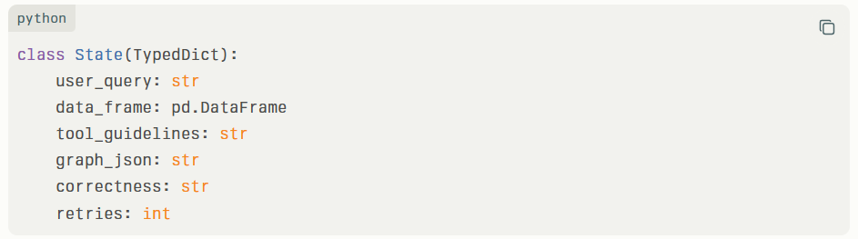
Fig. 8.1: State Definition For Langgraph Workflow (State Typeddict)
This state object moves through the graph, getting updated by each node as shown in Fig. 8.1.
8.1.1 Query Relevance Validation Implementation
The query_relevance_checker is the first node in the workflow, acting as a gate before any enhancement or processing occurs, as shown in Fig. 8 .2.
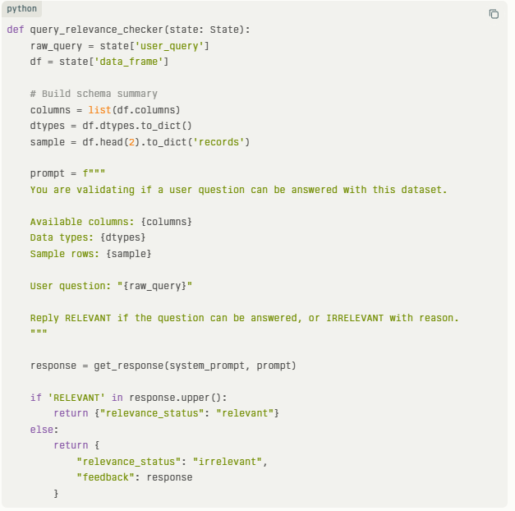
Fig. 8.2: Query Relevance Node Implementation (Code Snippet)
If the status is "irrelevant," the workflow terminates immediately and returns the feedback message to the user via Streamlit. This addresses Objective 1 by ensuring that only answerable queries proceed to enhancement and data preparation
8.1.2 Query Enhancer Node
The query_enhancer function calls the Perplexity API with a prompt that asks the model to rewrite the user's question as shown in Fig. 8.3.
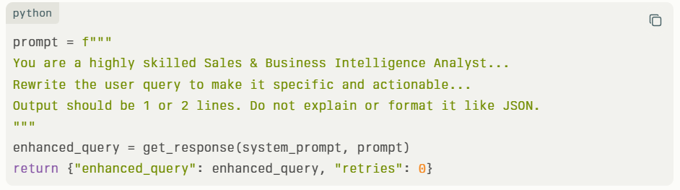
Fig. 8.3: Query Enhancer Node Implementation (Code Snippet)
The prompt includes guidelines to keep the rewritten query visualization-friendly and limited to supported chart types. This transforms vague questions like "How are sales doing?" into specific ones like "Compare total INR value across product categories using a bar chart."
8.1.3 Data Preprocessor Node
The data_preprocesser_node handles all data cleaning in one comprehensive function:
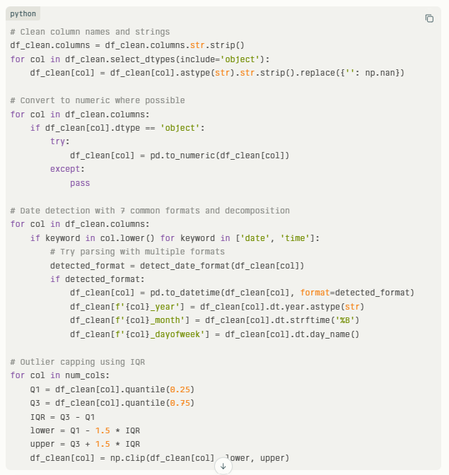
Fig. 8.4: Data Preprocessor Node Implementation (Code Snippet)
This single function transforms messy CSV data into clean, visualization-ready DataFrames with temporal features and outlier handling, shown in Fig. 8.4.
8.1.4 Plot Selector and Output Checker
The plot_selector prompts the LLM to generate structured JSON as shown in Fig. 8.5.
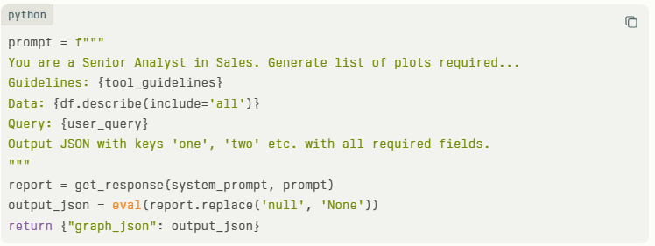
Fig. 8.5: Plot Selector Implementation (Code Snippet)
The output_checker validates this output as shown in Fig. 8.6.
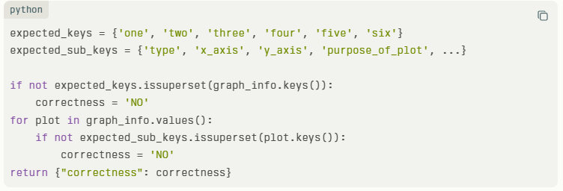
Fig. 8.6: Output Checker Implementation (Code Snippet)
8.1.5 Workflow Assembly
The graph connects everything as shown in Fig. 8.7.
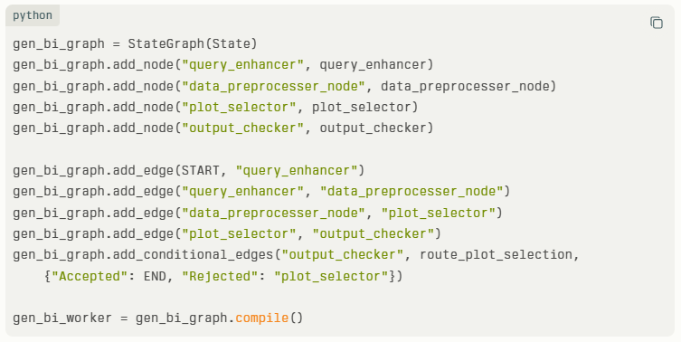
Fig. 8.7: Workflow Assembly and Graph Compilation Code
This creates a robust pipeline that automatically retries failed plot generations.
8.2 Dashboard Implementation
This section describes the implementation of the configuration-driven dashboard generation engine. The dashboard_tool.py module generates layouts and visualizations dynamically from the JSON specifications produced by the agentic workflow.
8.2.1 Dynamic Layout Generation
The main run_dashboard (df, all_plots) function builds the Dash app, code snippet in Fig. 8.8.
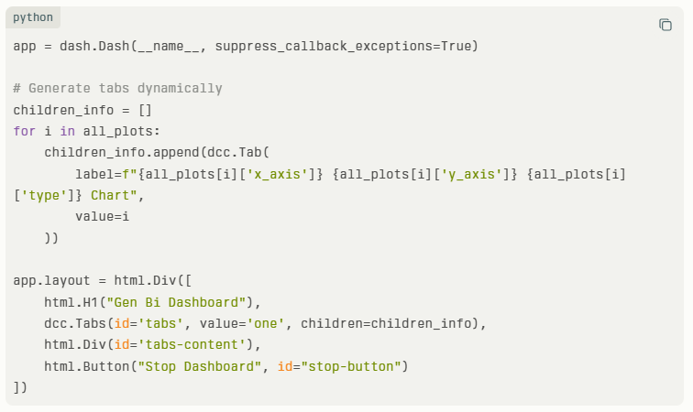
Fig. 8.8: Dynamic Dash Layout Generation (Run_Dashboard Function)
Tabs are created automatically based on the plot configuration, with descriptive labels.
8.2.2 Chart Type Implementation
The update_chart_sub_func handles all six chart types, sample code in Fig. 8.9.
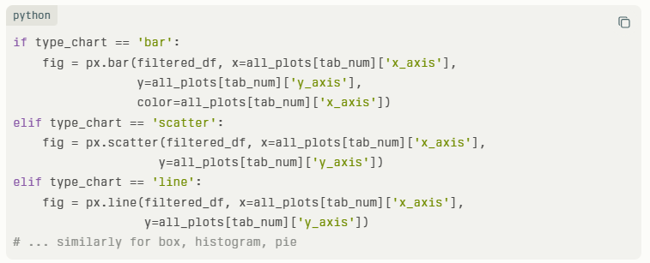
Fig. 8.9: Chart Type Implementation (Update_Chart_Sub_Func)
Each chart type uses Plotly Express with consistent styling (white backgrounds, appropriate colours).
8.2.3 Temporal Sorting
Special handling ensures time-based charts display correctly code in Fig. 8.10.
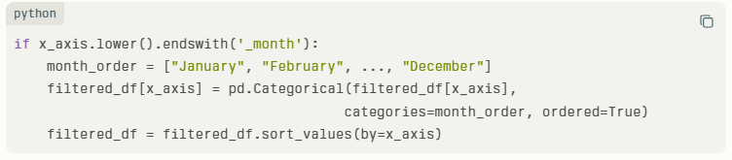
Fig. 8.10: Temporal Sorting Logic For Month And Day Of Week
This prevents months from appearing alphabetically (April, August, December...) and ensures chronological order.

8.3 Implementation of Filters
This section describes the implementation of interactive filtering functionality using Dash callbacks. The filtering mechanism enables real-time chart updates and supports exploratory data analysis through dynamic user interaction.
8.3.1 Filter UI Components
Code snippet for categorical filters in Fig. 8.11.
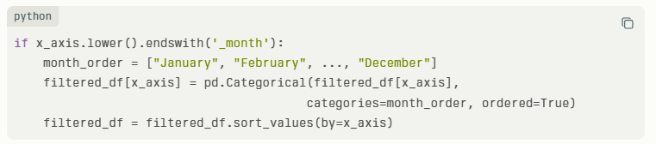
Fig. 8.11: Filter UI Components For Categorical Filters
Code snippet for numerical filters Fig. 8.12.
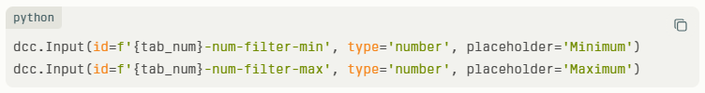
Fig. 8.12: Filter UI Components For Numerical Filters
8.3.2 Filter Application Logic
The callback applies filters sequentially as shown in Fig. 8.13.
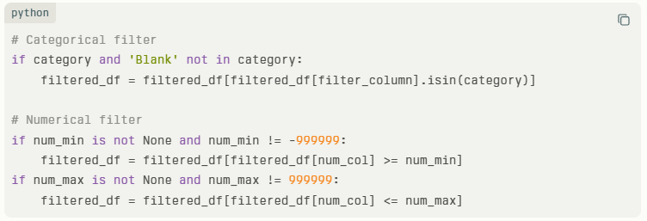
Fig. 8.13: Filter Application Logic (Categorical And Numerical)
Sentinel values (-999999, 999999) distinguish "no filter applied" from actual filter values.
8.3.3 Empty Data Handling
The code snippet for empty data handling shown in Fig. 8.14.
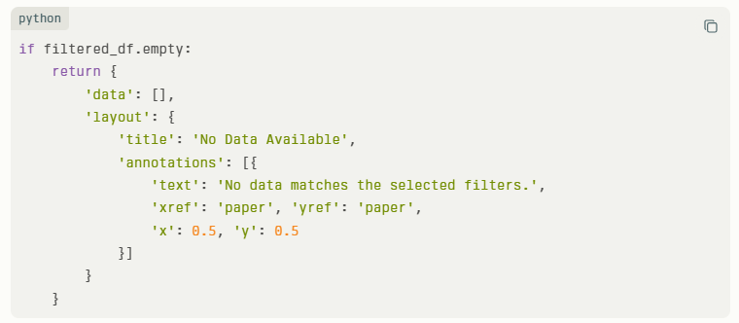
Fig. 8.14: Empty Data Handling Logic
This prevents crashes and gives users clear feedback.
8.4 Insight Generation Implementation
This section describes the implementation of the insight generation component. The system produces contextual business insights by preparing chart-specific analytical summaries and passing them to a Large Language Model for interpretation [3].
8.4.1 Chart-Specific Data Preparation
Bar, scatter, and line charts perform category-based, correlation, and time-series analysis respectively, as shown in Figs. 8.15–8.17.
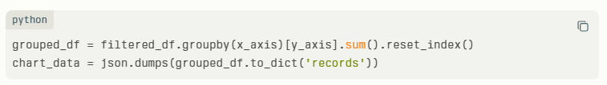
Fig. 8.15: Bar Chart Specific Insight Preparation Code

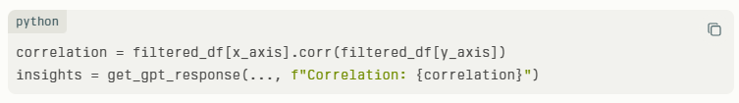
Fig. 8.16: Scatter Plot Specific Insight Preparation Code
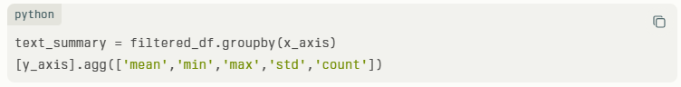
Fig. 8.17: Line Chart Statistics Calculation Code
8.4.2 Insight Prompt Engineering
Each insight call uses this structure:
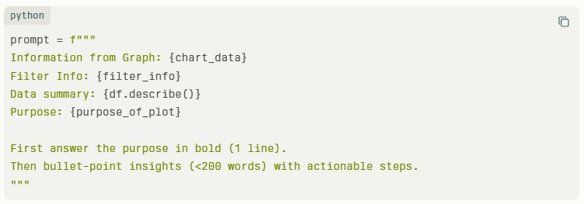
Fig. 8.18: Insight Prompt Engineering Code Snippet
The LLM returns formatted markdown that renders cleanly in the dashboard. Code snippet shown in Fig. 8.18.
8.5 Frontend Implementation
This section describes the implementation of the Streamlit-based user interface. The frontend simplifies interaction with the system by allowing users to submit natural language queries and access generated dashboards through a straightforward workflow.
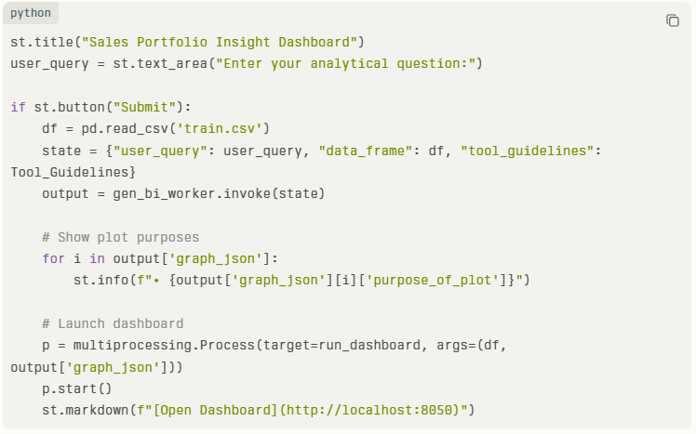
Fig. 8.19: Streamlit Frontend Implementation (Stream_Lit.Py)
Code shown in Fig. 8.19 creates a simple loop: question → workflow → preview → dashboard link.
8.6 Validation and Error Handling
Multiple layers prevent failures:
- Workflow validation: Output checker with retry logic.​
- Dashboard error handling: Try-catch around chart and insight generation.​
- Empty data handling: Informative messages instead of blank charts.​
- API failure handling: Graceful degradation with error messages.​
8.7 Summary
Agentic workflow (Agentic_Dashboard_v3.py) handles intelligence and data preparation. The dashboard engine (dashboard_tool.py) renders charts, filters, and insights. The frontend (stream_lit.py) makes everything accessible. Together, these implementations deliver a complete system that turns natural language questions into interactive, explained dashboards.

Chapter 9: Testing and Validation
The Dashboard was tested using functional and end-to-end validation scenarios to verify the correctness of query processing, dashboard generation, interactive filtering, and insight generation. Testing was performed using the complete system, including the Streamlit interface, LangGraph workflow, dashboard engine, and LLM-Powered insight generation components.
9.1 Functional Test Results
The system was evaluated using representative business intelligence scenarios.
Table 9.1: Functional Test Results
Test ID | Test Scenario | Expected Result | Outcome
TC01 | Valid business query | Dashboard generated successfully | Pass
TC02 | Irrelevant query | Query rejected with feedback | Pass
TC03 | Multi-visualization request | Multiple dashboard views generated | Pass
TC04 | Interactive filtering | Charts updated correctly | Pass
TC05 | Insight generation | Business insights generated | Pass
All tested steps were completed successfully without workflow failures, shown in Table 9.1.
9.2 Performance Validation
To evaluate operational performance, key system metrics were recorded during testing are shown in Table 9.2
Table 9.2: Performance Validation Metrics
Metric | Result
Average Dashboard Rendering Time | Under a minute
Query Processing Success Rate | 100% (tested queries)
Dashboard Generation Success Rate | 100% (tested scenarios)
Filter Response Time | Near real-time
Insight Generation Availability | Generated for all tested dashboards
The results indicate that the system can generate dashboards and insights within a few minutes while maintaining interactive performance on standard hardware.
9.4 End-to-End Validation
To validate the complete analytical workflow, two representative business queries were executed through the proposed system. The evaluation considered the performance of the LangGraph-based agentic workflow, dashboard generation process, and interactive dashboard responsiveness. The end-to-end validation results are presented in Table 9.3.
Table 9.3: End-to-End Validation Results
User Query | Enhanced Query | Processing Time | Dashboard Response Time* | Charts | Result
Tell me about the sales | Show total sales by month in a bar chart and show the top distributors by total sales in a pie chart | 23 s | < 10 s | 2 | Success
Which distributor generated the highest sales value? | Create a bar chart showing total sales value by distributor and identify the highest-performing distributor | 26 s | < 10 s | 1 | Success
*Dashboard Interaction Response Time refers to the average response time observed during dashboard tab switching and filter updates.
For the query “Which distributor generated the highest sales value?”, the system successfully transformed the natural language request into a structured analytical instruction and generated an appropriate visualization showing distributor-wise sales performance, as illustrated in Fig. 9.1. The system also generated contextual business insights from the visualization, as shown in Fig. 9.2. The generated dashboard enabled users to quickly identify the highest-performing distributor and compare sales performance across distributors.
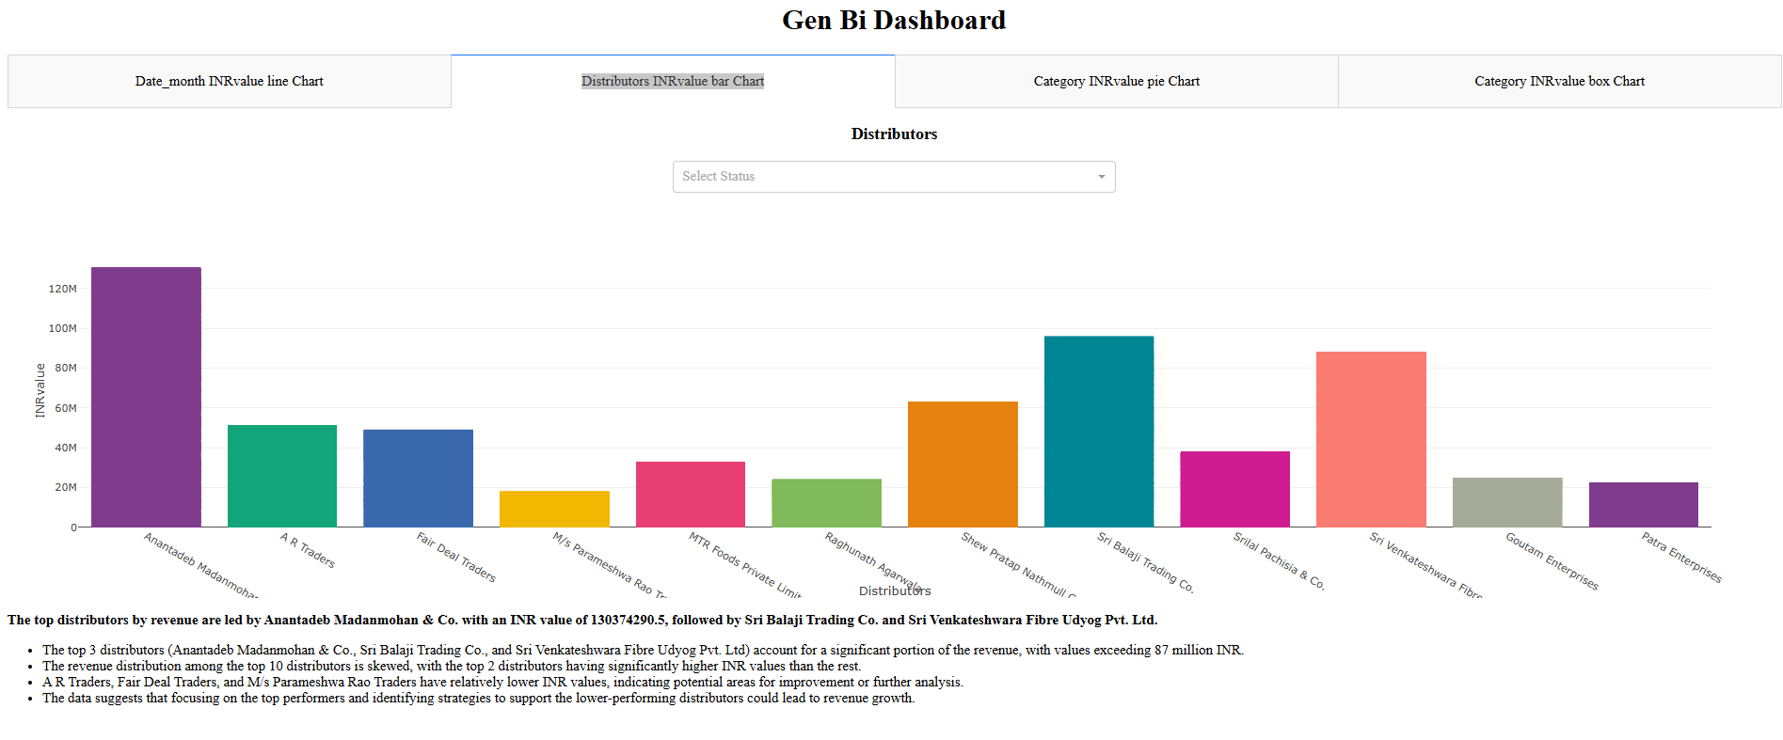
Fig. 9.1: Distributor-Wise Sales Bar Plot (System Output)

Fig. 9.2: Distributor Performance Insights (System Output)
Similarly, for the query “Tell me about the sales”, the system generated multiple visualizations and corresponding business insights. The query enhancement component successfully converted the user request into a structured analytical instruction that was processed by the agentic workflow. The resulting dashboard provided an overview of monthly sales trends and distributor contributions, demonstrating the system’s ability to transform natural language business questions into meaningful analytical outputs.
9.5 Summary
The testing results confirm that the proposed system successfully performs natural language query processing, dashboard generation, interactive filtering, and automated insight generation within a unified workflow. All tested scenarios produced valid outputs, and dashboard generation was completed within few minutes, demonstrating the effectiveness of the proposed solution for interactive business intelligence applications.

Chapter 10: Analysis and Results
The analysis focuses on evaluating how effectively the proposed system achieved the four objectives defined in Chapter 4. Each section of this chapter examines one objective and discusses the results obtained during implementation and testing. The findings provide an overview of the system's performance and demonstrate its ability to support natural language-driven business intelligence and data analysis.
10.1 Design an Intelligent Workflow for Natural Language-Driven Business Data Analysis and Visualization.
The first objective focused on designing an intelligent workflow capable of interpreting user queries, preparing data, selecting appropriate visualizations, and validating generated outputs. The results demonstrate that the proposed agentic workflow successfully transformed natural language requests into structured analytical instructions through the coordinated operation of the Query Relevance Checker, Query Enhancer, Data Preprocessor, Plot Selector, and Output Validator.
Testing confirmed that relevant queries were processed correctly while unsupported queries were identified and handled appropriately. The workflow consistently generated valid dashboard configurations, demonstrating that the proposed architecture effectively supports automated analytical processing. The results indicate that the agentic workflow improved the reliability and consistency of query processing by applying validation and verification at different stages of the analytical process.
10.2 Develop an Interactive Dashboard for Dynamic Data Exploration and Visualization Generation.
The second objective focused on developing an interactive dashboard capable of generating visualizations dynamically and supporting data exploration through user interaction. The implemented system successfully generated dashboards based on natural language queries without requiring users to manually create charts or configure dashboard components.
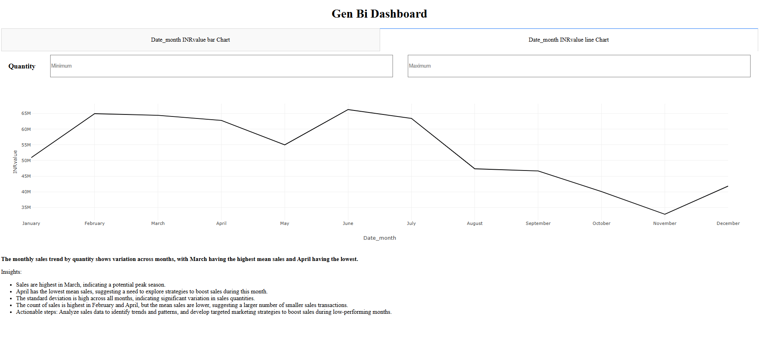
Fig. 10.1: Monthly Sales Value Trend Using a Line Chart
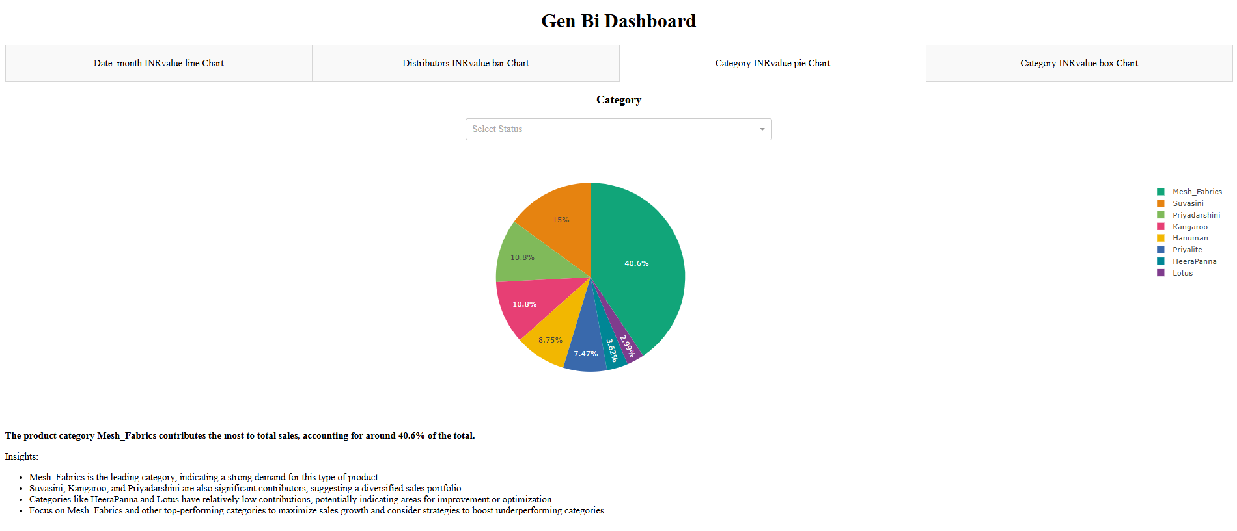
Fig. 10.2: Category-Wise Sales Distribution Using a Pie Chart
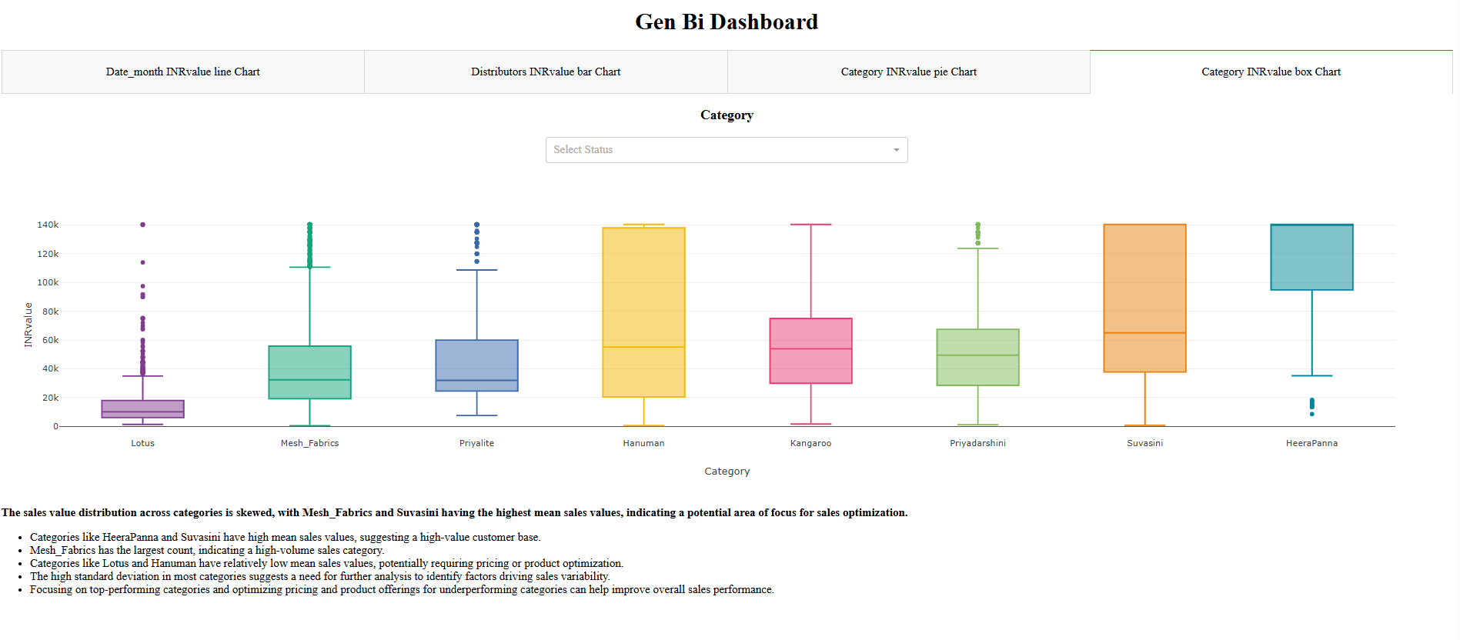
Fig. 10.3: Category-Wise Sales Value Distribution Using a Box Plot
Figures 10.1–10.3 present examples of dashboards generated by the proposed system from the uploaded sales transaction dataset. Based on the user's query and the characteristics of the data, the system automatically selected appropriate visualization types and generated contextual business insights. Interactive filters were also provided, enabling users to refine and explore the data dynamically.
Figure 10.1 illustrates the monthly sales value trend throughout the year using a line chart. The visualization highlights fluctuations in sales performance across different months, enabling users to identify periods of higher and lower business activity. In addition, the system automatically generated insights summarizing key trends observed in the chart. Such analysis can assist organizations in understanding seasonal patterns, planning inventory requirements, and supporting sales forecasting activities.
Figure 10.2 presents the contribution of different product categories to total sales value using a pie chart. The visualization provides a clear overview of category-wise revenue distribution and helps identify the major contributors to overall sales performance. Alongside the chart, the system generated insights highlighting the most significant categories and their relative contributions. This type of analysis supports product portfolio evaluation, resource allocation, and category-level business planning.
Figure 10.3 shows the distribution of sales values across product categories using a box plot. The visualization highlights variations in sales performance, differences in transaction values, and the presence of outliers across categories. The generated insights summarized the observed distribution patterns and identified categories exhibiting higher variability. Such information can help businesses understand category performance, detect unusual sales behaviour, and identify opportunities for further investigation and optimization.
The generated dashboards demonstrate the ability of the proposed system to automatically create suitable visualizations, integrate interactive filtering mechanisms, and produce meaningful business insights without manual intervention. These capabilities simplify the process of business intelligence reporting and enable users to explore data and obtain actionable insights through a natural language-driven interface.

10.3 Evaluate the Accuracy, Reliability, and Effectiveness of Analytical Outputs and Insights.
The third objective focused on evaluating the accuracy, reliability, and usefulness of the generated outputs. Functional testing and end-to-end validation demonstrated that the system consistently generated dashboards, applied filters correctly, and produced contextual business insights.
The testing results showed successful execution across all evaluated scenarios. Validation also confirmed that generated insights accurately reflected the information presented in the visualizations. These findings suggest that the proposed solution provides reliable analytical outputs suitable for business intelligence applications. The performance evaluation showed that most tested business queries were processed within 60 seconds, including dashboard generation and insight creation.The successful completion of all tested scenarios indicates that the proposed system can provide reliable analytical outputs for business intelligence applications.
10.4 Deploy an Accessible Business Intelligence Solution for Intuitive Decision Support and Reporting.
The fourth objective focused on delivering an accessible business intelligence environment for both technical and non-technical users. The Streamlit-based interface enabled users to upload datasets, submit natural language queries, and access generated dashboards through a simple workflow.
The system required minimal user interaction and eliminated the need for manual visualization configuration, SQL queries, or programming knowledge. This demonstrates that the proposed solution improves accessibility to business intelligence tools and supports self-service analytical exploration.Natural language interaction reduces the technical barriers associated with traditional business intelligence tools and makes data exploration more accessible to a wider range of users.
10.5 Results Summary
The overall results indicate that the proposed system successfully achieved the objectives established for the study.
In addition to meeting the defined objectives, the system demonstrated the ability to generate dashboards and business insights within a few minutes while maintaining interactive performance and usability. The integration of natural language processing, agentic workflow orchestration, automated visualization generation, and LLM-Powered insight creation provides a practical approach to modern business intelligence.

Chapter 11: Conclusions and Future Scope
11.1 Conclusions
LLM-Powered dashboard is built that takes natural language questions and turns them into interactive charts with explanations in a few minutes, without manual dashboard design. The LangGraph workflow coordinates query enhancement, data cleaning, plot selection, and validation, while the Dash layer renders charts and GPT generates narrative insights that match what is shown on the screen. Tests with queries such as “Tell me about the sales” and Which distributor generated the highest sales value” showed total response times within minutes and produced correct visualizations and useful, action-oriented insights.​
11.2 Contributions and Limitations
The main contributions are:
- A working end-to-end prototype from question to dashboard and insights.
- A practical agentic design using LangGraph and LLMs for query and plot generation.
- A reusable Dash dashboard that supports multiple chart types and dynamic filtering.​
Key limitations are the focus on six basic chart types, in-memory processing on a single machine, and reliance on an external LLM API, which affects scalability, cost, and offline use.​
11.3 Future Scope
Future work can extend the system with richer visualizations (for example, heatmaps or treemaps), better handling of very large datasets through aggregation or database integration, and support for multiple or on-premise language models to reduce dependency on a single provider. Deploying the solution on a shared server for multi-user access and running longer-term user studies inside an organization would also help measure its real impact on decision-making and analyst workload.​

Bibliography

[1] A. Wu et al., “AI4VIS: Survey on Artificial Intelligence Approaches for Data Visualization.” [Online]. Available: http://csrankings.org/
[2] Y. Luo, N. Tang, G. Li, J. Tang, C. Chai, and X. Qin, “Natural Language to Visualization by Neural Machine Translation.” [Online]. Available: https://github.com/Thanksyy/ncNet
[3] M. Mersha, K. Lam, J. Wood, A. AlShami, and J. Kalita, “Explainable Artificial Intelligence: A Survey of Needs, Techniques, Applications, and Future Direction,” Jan. 2025, doi: 10.1016/j.neucom.2024.128111.
[4] N. Bikakis, “Big Data Visualization Tools,” in Encyclopedia of Big Data Technologies, Springer International Publishing, 2022, pp. 1–8. doi: 10.1007/978-3-319-63962-8_109-2.
[5] A. Wu et al., “MultiVision: Designing Analytical Dashboards with Deep Learning Based Recommendation,” Jul. 2021, [Online]. Available: http://arxiv.org/abs/2107.07823
[6] C. North, “Toward measuring visualization insight,” IEEE Comput. Graph. Appl., vol. 26, no. 3, pp. 6–9, May 2006, doi: 10.1109/MCG.2006.70.
[7] LangChain, “LangGraph: Build Stateful Multi-Actor Applications with LLMs,” https://langchain-ai.github.io/langgraph/.
[8] G. Ouyang et al., “NVAGENT: Automated Data Visualization from Natural Language via Collaborative Agent Workflow,” 2025. [Online]. Available: https://github.com/
[9] S. Few, “Dashboard Design for at-a-glance monitoring,” 2010. [Online]. Available: www.perceptualedge.com
[10] B. Shneiderman, “The Eyes Have It: A Task by Data Type Taxonomy for Information Visualizations.”
[11] “Team Data Science Process,” https://www.datascience-pm.com/tdsp/.
[12] V. J. Hodge and J. Austin, “A Survey of Outlier Detection Methodologies,” 2004.

Plagiarism Report

Github Link

https://github.com/Shyamsundarkanaka/LLM-Powered-Agentic-Dashboard-for-Business-Intelligence

